*NucE 497 Fuel Performance Exam 2 covering modules 1 – 3*

*Name:*

**Question 1 (25 points):**

The temperature and gap width of a fuel pellet, as predicted by a fuel performance code, is shown below. Using the plots as your guide, determine what is currently occurring within the cladding, gap, and pellet at each number. Note that the numbers are at the same burnups on each plot

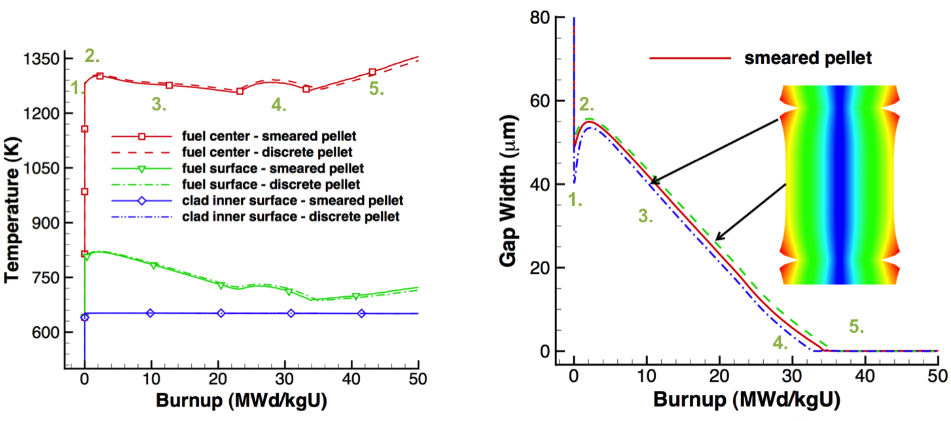

For each number, describe what is occurring in the cladding, gap, and pellet. Also, describe what features in the plots indicated these behaviors.

1. The fuel heats up, causing thermal expansion in both the fuel and the cladding. 2.5 This decreases the gap width. 2.5

2. The fuel densifies, 2.5 causing the gap width to increase and causing the temperature to increase. 2.5

3. The fuel swells (1) and the gap creeps down (1), decreasing the gap width (1). This causes the temperature to decrease (2).

4. The fuel continues to swell and the gap to creep down (1), but fission gas is also being released into the gap (2), causing the temperature to go up before continuing downward (2).

5. The gap and cladding have come into contact (2.5). The gap thickness stays zero from now on, but the temperature steadily rises due to the decreasing thermal conductivity of the fuel (2.5).

**Question 2 (30 points)**

A fuel pellet with an average grain size of 8 microns is irradiated with a volumetric neutron flux of 2.0e13 fissions/(cm3 s). Assume the pellet is at a uniform temperature of 900 °C.

1. What is the fission gas diffusion coefficient at this temperature? (5 pts)

T = 900 + 273.15 = 1173.15; 1 pt

D1 = 7.6e-6*exp(-3.03./(kb * T) ) = 7.3134e-19; 1 pt

D2 = 1.41e-18 * exp(-1.19./(kb * T) ) * sqrt(frate) = 4.8704e-17; 1pt

D3 = 2.e-30 * frate = 4.0e-17; 1pt

D = D1+D2+D3 = 8.94e-17 cm2/s 1pt

1. How many gas atoms/cm3 are released from the fuel after 2 years of irradiation? Assume the chain yield y = 0.3017. (10 pts)

t = 2*365*24*3600;%s (1 pt)

y = 0.3017;

gas_produced = t*y*frate = 3.8058e+20 (3 pts)

tau = D*t/a^2 = 0.0088 (1 pt)

f = 4*sqrt(D*t/(pi*a^2))-3/2*D*t/a^2 = 0.1986 (3 pts)

gas_released = gas_produced*f = 7.56e+19 gas atoms/cm3 (2 pts)

1. After 2 years of irradiation, the pellet is removed from the reactor and from its cladding, venting all released gas. It is then moved to a furnace and annealed at 2000 °C. Estimate how long before 10% of the gas trapped in the pellet is released. How many gas atoms/cm3 will have been released during this time? (15 pts)

T = 2000 + 273.15 = 2273.15 K (1 pt)

D1 = 7.6e-6*exp(-3.03./(kb * T) ) = 1.4556e-12

D2 = 1.41e-18 * exp(-1.19./(kb * T) ) * sqrt(frate) = 1.4501e-14

D3 = 2.e-30 * frate = 4.0e-17;

D = D1+D2+D3 = 1.4701e-12; (3 pts)

frac = 0.1;

t = pi*a^2*frac^2/(36*D) = 380.0 s (6 pts)

gas_released_post = gas_produced*(1-f)*frac = 3.05e+19 gas atoms/cm3 (5 pts)

**Problem 3 (30 points)**

A ZIRLO cladding tube is in reactor at 600 K for one year. The initial wall thickness is 0.6 mm.

1. What is the hydrogen pickup in mg/dm2 after this time? (10 pts)

dstar = 5.1*exp(-550/T) = 2.0392 (2 pts)

tstar = 6.62e-7*exp(11949/T) = 295.0072 (2 pts)

KL = 7.48e6*exp(-12500/T) = 0.0067 (2 pts)

delta = dstar + KL*(t - tstar) = 2.5082 microns (2 pts)

w = 14.7*delta = 36.87 mg/dm2 (2 pts)

1. What is the ZIRLO wall thickness after this time? (5 pts)

Th_lost = delta/1.56 = 2.5082/1.56 = 1.6078 microns (2.5 pts)

thw_new = thw*1e3 - delta/1.56 = 598.39 microns (2.5 pts)

1. Assuming a hydrogen pickup fraction is 15%, what is the weight PPM of hydrogen in the cladding after one year? δZrO2 = 5.68 g/cm3 and δZr = 6.5 g/cm3 (10 pts)

f = 0.15;

dens_oxide = 5.68; %g/cm3

dens_zr = 6.5; %g/cm3

fo = 32/(91+32) = 0.2602; (2 pts)

MH = 1;

MO = 16;

CH = 2*f*delta*dens_oxide*fo*MH/MO*1e6/((thw*1e3-delta/1.56)*dens_zr) (4 pts)  
CH = 2*0.15*2.5082*5.68*0.2602*(1/16)*1e6/((600 – 2.508/1.56)*6.5) = 17.87 wt ppm (4 pts)

1. Draw a section of the cladding, showing the various microstructure changes (5 pts)

Oxide layer (2 pts)

Circumferential hydrides (2 pts)

Radial hydrides (1 pts for at least one other feature)

Hydride rim

Blister

CRUD

**Problem 4 (15 points)**

1. What are the primary differences between a loss of coolant accident and a reactivity insertion accident, regarding the fuel and cladding behavior? (5 pts)

In a RIA, the source term Q jumps very quickly. This rapid increase in heat production causes the fuel to expand rapidly and hit the cladding. The fuel fragments to very small pieces.

In a LOCA, the BC changes, but not as quickly. The temperature in the cladding and the fuel both rise, causing ballooning and eventual rupture. The fuel fragments but the pieces are typically larger. Fuel more likely to melt, because time scale is shorter

Time scale (2 pts)

RIA changes Q, LOCA changes BC (2 pts)

Details (1 pt)

1. What are similarities between the fuel and cladding behavior in RIA and a LOCA? (5 pts)

fuel fragments

temperatures go very high.

Cladding can balloon and rupture, possibly resulting in fuel release and melting

1. List a potential accident tolerant fuel concept and describe how it will meet the primary goal of the accident tolerant fuel program. (5 pts)

Coated cladding. It prevents rapid oxidation of the cladding in high temperature steam, preventing hydrogen production. This provides more time before things blow up and cladding oxidizes away.

Correct concept (2.5pts)

List benefits (2.5 pts)